**ASSIGNMENT 4**

**Wired Networks**

Wired networks use **physical cables** to connect devices. These cables carry data signals and connect each device to the network through a router or switch.

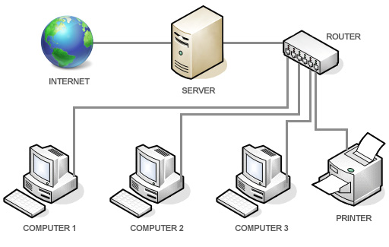

**Advantages of Wired Networks:**

* High speed and reliable connection
* More secure compared to wireless
* Less interference from other devices

**Types of Wired Networks:**

1. **Ethernet (LAN – Local Area Network):**
   * The most common type of wired network.
   * Used in homes, offices, schools, and colleges.
   * Computers, printers, and other devices are connected through Ethernet cables.
2. **Coaxial Cable Network:**
   * Common in older TV cable systems and internet connections.
   * Still used in some broadband internet setups.
3. **Fiber Optic Network:**
   * Uses light signals instead of electrical signals.
   * Very high speed and supports long-distance communication.
   * Used by ISPs (Internet Service Providers) and in large companies or data centres.

**Wireless Networks**

Wireless networks use **radio signals, microwaves, or infrared signals** to connect devices without any physical cables. Devices communicate through wireless routers or antennas.

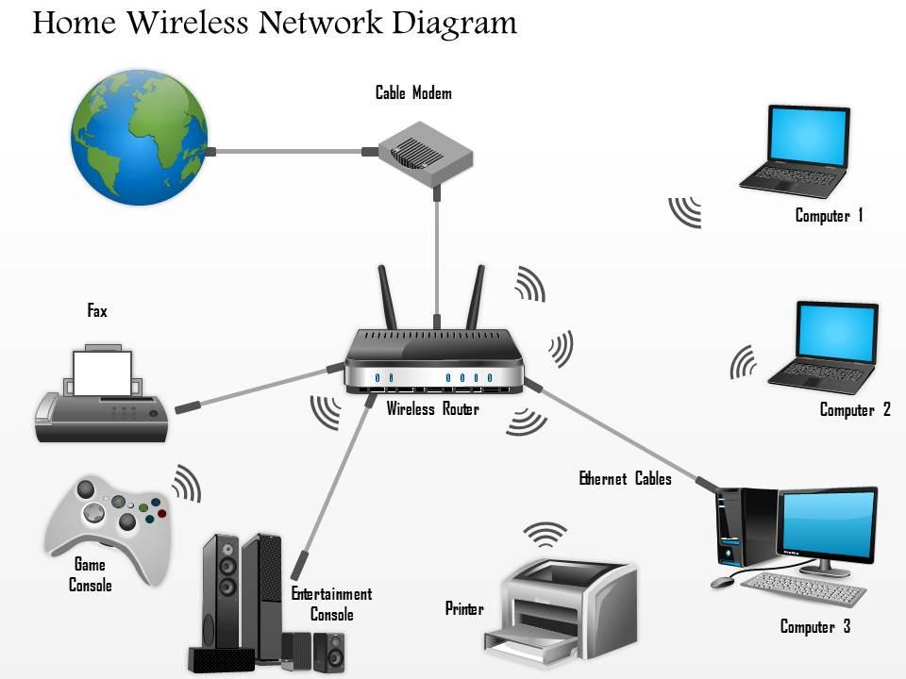

**Advantages of Wireless Networks:**

* Easy to set up—no cables needed
* Offers mobility—you can move around while staying connected

**Types of Wireless Networks:**

1. **Wi-Fi (Wireless LAN):**
   * The most popular wireless network.
   * Used in homes, cafes, schools, and offices.
   * Devices connect to a router wirelessly to access the internet.
2. **Bluetooth:**
   * Used for short-distance connections.
   * Commonly used to connect mobile phones to headphones, speakers, or car audio systems.
3. **Mobile Networks (3G, 4G, 5G):**
   * Used by smartphones and tablets.
   * Allow internet access through SIM cards using cell towers.
   * 5G offers very high speeds with low delay.
4. **Infrared and Satellite:**
   * Infrared is used for very short distances (like remote controls).
   * Satellite networks are used where other networks are not available, like in remote areas or for television broadcasting.